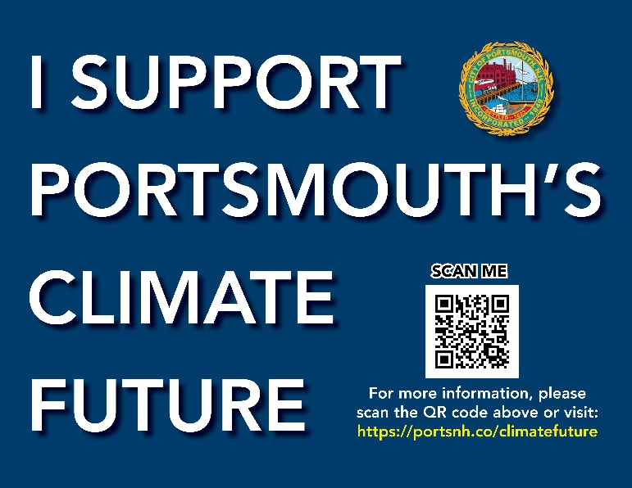
CLIMATE AMBASSADOR
ACTIVITY GUIDE
AND NOTES

YOUR NAME:

GROUP NAME:

MEETING LOCATION & TIME:

GROUP CONTACT PERSON:

NUMBER OF PARTICIPANTS IN ROOM:

NOTE FOR AMBASSADORS: Thank you for your assistance as a Climate Ambassador to help create Portsmouth’s Climate Action Plan! As you join groups, follow the facilitation guide below and take notes to record participant input. Print out the guide for easy reference.

Meeting Tips:
- Create a comfortable setting: join groups as they are or set up a circle of chairs or tables.
- Encourage participation: Use a ‘round robin’ format, inviting each person to share a brief idea or for larger groups use pop-ups or a combination.
- Feel free to establish ground rules – speak one at a time, listen without judgement, be kind, etc.
- Take notes on a laptop within this guide or hand write notes within the guide. Summarize key points in bullet notes (legibility is very important, spelling is not).
- Submit a group’s information by email, drop off at City Hall, or photograph notes and attach in an email. Send to Kate Homet at kehomet@cityofportsmouth.com

Start: Welcome: “My name is ____ and I am volunteering as a Climate Ambassador to gather community input about how Portsmouth as a city should address the challenge of Climate Change. More on what that is and how we’re collecting information in a minute. First, let’s do very quick introductions.”

5 Min. Introductions: In one word - what is your biggest climate concern?
- Everyone in the room: Name and one word climate concern. (< 30 sec. each)
- TAKE NOTES on the one concern.

5 Min. Overview: Today we are discussing Portsmouth’s Climate Future an initiative to create a Climate Action Plan for the City.

Acknowledging the Climate Crisis​:
To set the stage for this discussion we would like to share some facts from Meeting #1 on May 4th:
- The climate crisis is one of the greatest environmental challenges of the 21st century, posing serious threats to public health and safety and the built environment, particularly in coastal areas, such as the City of Portsmouth.​

- Since the beginning of the 20th century, temperatures in New Hampshire have risen by 3 degrees Fahrenheit on average. Future warming will impact snowfall/snow cover, annual average precipitation, and the frequency and intensity of extreme precipitation events with associated increases in regional flooding.​

- Municipalities and their communities play a key role in addressing the climate crisis and must focus on mitigating their GHG emissions and building overall climate resilience to current and future climate change impacts through adaptation and preparedness measures.​
How does your input inform the Climate Action Plan?
We need a wide range of participation to help us determine how Portsmouth can address the climate crisis. Over the next two months we will be asking the community for input and direction. Your ideas are written down as a group and are not individually attributed to you. All ideas are welcome and encouraged! You are also welcome to pass. This activity is designed to move quickly and gather your ideas. We don’t have time for lengthy discussion today and we’ll respect each other and our 60-minute timeframe. Find more information on the City’s website. Thank you for your participation!

15 Min. Question 1. Where and how can Portsmouth reduce Greenhouse Gas (GHG) Emissions?

This could include City (government operations) and Community (mainly residential, commercial, and institutional activities) efforts to mitigate (reduce or prevent) GHG emissions.

- Energy. Examples include existing building retrofits, new construction green building standards, renewable energy installations (e.g., solar photovoltaics, geothermal), and transitioning away from fossil fuels, namely natural gas, propane, and fuel oil.

- Transportation. Examples include reducing vehicle miles traveled on local roadways via public transit service and active transportation infrastructure (e.g., commuter trails, scooter or bike sharing) or through land use policies that promote walkability and local needs production (e.g., food), as well as by promoting electric vehicle adoption.

c. Waste Management. Examples include mandating residential and commercial food waste collection and composting, expanding the recycling program and list of accepted materials, promoting material reuse, and instituting a pay-as-you-throw program.
d. Land Management. Examples include afforestation/reforestation (i.e., planting trees), land preservation, wetland enhancement, and zoning for land uses that support the green economy (e.g., offshore wind).

10 Min. Question 2. What are the barriers you, or others, face in personally supporting the solutions you identified under Question #1?

5 Min. Question 3. How aggressive should the City and Community be in reducing GHG emissions?

Potential options include:
i. Establishing reduction targets in line with the state (i.e., 80% below 1990 levels by 2050), ii. Applying science-based targets, similar to Dover (i.e., targets that align with limiting global temperature increases to 1.5°C above pre-industrial levels),
iii. Seeking net zero status (i.e., removing all emissions under the City’s direct control or generated from activities occurring within the Community’s geographic boundary), or
iv. Seeking carbon neutral status (i.e., balancing emissions generation with emissions removal relating to all emissions generated under the City’s direct and indirect control or from/resulting from activities occurring within the Community’s boundary).

5 Min. Question 4. How have the climate hazards presented today affected you or others that you know? Which do you believe are priorities to address? Are there others?

5 Min. Question 5. How should the City prioritize its climate action investments?
- Consider criteria such as GHG emissions reduction, cost effectiveness, potential to improve community well-being, economic benefits, co-benefits with climate adaptation/resilience, equity and justice, impact to the City’s annual budget, and alignment with regional priorities.

5 Min. Question 6. Are there particular population groups you are more worried about over others regarding their ability to contribute to or benefit from the City’s climate action efforts, or their vulnerabilities to the discussed climate hazards? How can the City integrate their unique perspectives and needs into the planning process?

5 Min. Question 7. How can the City promote education and awareness of its climate action goals and activities?

Thank you! For more information visit the project website: https://portsnh.co/climatefuture

Consider signing up for Bright Action as well! You can join others in Portsmouth who are taking action!
https://brightaction.app/newhampshire/portsmouth

For questions, please contact Kate Homet at kehomet@cityofportsmouth.com

